MBSE_Class_7_11_2020_Demo

Requirement Report

Author: <Author name>

Revision: 0.1

|  |  |
| --- | --- |
| NA |  |
| NA | Date: July 25, 2020 |

**Revision History**

|  |  |  |  |
| --- | --- | --- | --- |
| **Revision** | **Date** | **Reason For Changes** | **Author** |
| 1.0 | Jan 02, 1990 | <Release> | <Author Name> |
| 0.1 | Jan 01, 1990 | <Initial draft> | <Author Name> |
|  |  |  |  |

**Table of Contents**

Microsoft Word users please click here and press F9 to create Table of Contents.

OpenOffice.org users please remove this text and select Insert Table of Content from menu.

**Table of Figures**

Microsoft Word users please click here and press F9 to create Table of Contents.

OpenOffice.org users please remove this text and select Insert Table of Content from menu.

**Executive Summary**

This section previews the main points of a report. The executive summary contains enough information for a reader to get familiarized with what is discussed in the full report without having to read it.

# Introduction

## Purpose

<This document provides requirements with their properties including requirement id, requirement name, requirement text and the dependencies.>

## Scope

<Provide a short description of the system being specified and its purpose, including relevant benefits, objectives, and goals.>

## Overview

<Describe what the document contains and explain how the document is organized>

# 1 Connect to Mains Power

The CMS shall connect to mains power.

**Verify Method:**

Inspection

# 2 Maximum Water Temperature

The CMS shall heat water to 100C in 2 minutes.

**Verify Method:**

Demonstration

**Derived From:**

|  |  |
| --- | --- |
| -557300875.png | 7 Brew Volume |

**Satisfied By:**

|  |  |
| --- | --- |
| 1565148791.png | Heat Water |

**Verified By:**

|  |  |
| --- | --- |
| -607286236.png | Measure Temperature Rise |

**Traced From:**

|  |  |
| --- | --- |
| 1565148791.png | Heat Water |

|  |  |
| --- | --- |
| -607286236.png | Measure Temperature Rise |

# 3 Brewing Volume Selection

The CMS shall dispense coffee in thress user-selectable volumes.

**Verify Method:**

Demonstration

**Refined By:**

|  |  |
| --- | --- |
| -1096812108.png | Dispense Coffee |

**Satisfied By:**

|  |  |
| --- | --- |
| 1565148791.png | Dispense Coffee |

**Traced From:**

|  |  |
| --- | --- |
| 1565148791.png | Dispense Coffee |

## 3.1 Dispense 8 oz.

The CMS shall dispense 8 oz of coffee upon user request.

**Verify Method:**

Test

## 3.2 Dispense 12 oz.

The CMS shall dispense 12 oz of coffee upon user request.

**Verify Method:**

Test

## 3.3 Dispense 16 oz.

The CMS shall dispense 16 oz of coffee upon user request.

**Verify Method:**

Test

# 7 Brew Volume

The CMS shall brew 64 oz of coffee in not more than 5 minutes.

**Verify Method:**

Test

**Derived:**

|  |  |
| --- | --- |
| -557300875.png | 2 Maximum Water Temperature |

**Traced From:**

|  |  |
| --- | --- |
| -557300875.png | 2 Maximum Water Temperature |

## 7.1 Water Volume

The CMS shall store at least 64 oz of water

**Verify Method:**

Inspection

# Appendix A: Diagram

## CMS Requirements

NA

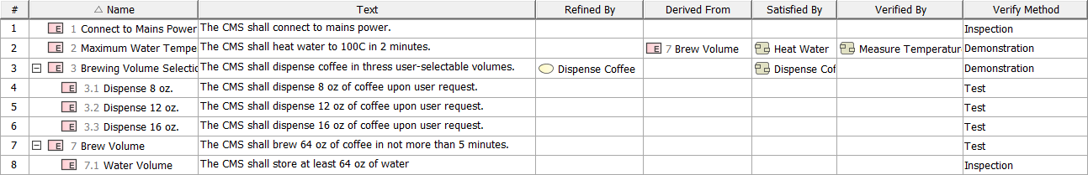

1. CMS Requirements